Information about the Statistical Office in Opole
in Easy to Read language (ETR)

Statistical Office in Opole is
- At Ks. Hugona Kołłątaja 5B street (main building):
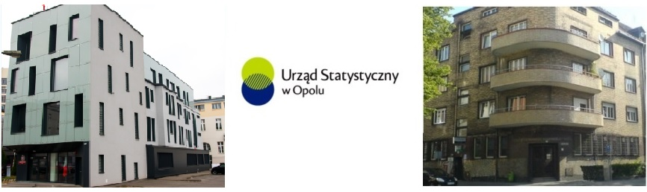

- At Ks. Hugona Kołłątaja 14 street:

Our office is headed by the Director, Ms. Renata Wasilewska.
The Director is assisted in her work by the office staff.

What does our Office do?
- collects data
- processes and publishes results
- conducts censuses and other important surveys
Our interviewers visit the homes or call the randomly selected and conduct interviews with them. You can verify the interviewer’s identity at website
https://sa.stat.gov.pl/formularz/ or by calling a number +48 22 279 99 99.

What can you handle at our Office?
- REGON number – number, which every company and entrepreneur must have,
- submit an application to deregister a company,
- order statistical information,
- submit required statistical forms.

Contact us.
- send a letter
Statistical Office in Opole
ul. ks. Hugona Kołłątaja 5B
45-064 Opole
- bring the document to the Office – księdza Hugona Kołłątaja 5B street,
- send mail to address: SekretariatUSopl@stat.gov.pl,
- call of these phone numbers: 77 423 01 10 or 77 423 01 11,
- visit the service point at księdza Hugona Kołłątaja 14 street.

Assistance for people with disabilities:

Building at ks. Hugona Kołłątaja 5B street:
- wheelchair ramp at the entrance, | 
- elevator adapted for persons with disabilities (audio announcements, buttons with Braille), | 
- the restroom for persons with disabilities is on the ground floor | 
- the widths of the corridors and room entrances are appropriate.

Building at księdza Hugona Kołłątaja 14 street:

- there are stairs but a call button for staff assistance is located on the left (there is no passenger lift),
- toilet for persons with disabilities is on the ground floor,
- the widths of the corridors and room entrances are appropriate.

If you are a person with special needs, please let inform the doorman or an Office employee, who will assist you
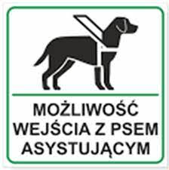
You may enter with an assistance dog.


You can use the services of a Polish sign language interpreter. Please request an interpreter 2-3 days in advance:
phone: 77 423 10 00,
e-mail: SekretariatUSopl@stat.gov.pl .

